1.0 Introduction
I considered the module Numerical Analysis a very important part of my learning process, as I understand it as a core component in machine learning. I had invested much time in this module and this reflection details about my learning journey.
2.0 Knowledge gained throughout this module
Throughout this module, I have acquired the following statistical analysis knowledge and hand-on experience on performing the analysis with R Studio software.
- Good understanding of the terminologies, Population, Parameter, Sample, Statistic, independent and dependent variables.
- Experience in installing and running R studio software, importing and exporting datasets.
- Learned about different variable types: Quantitative data such as discrete and continuous (ratio, interval) and Qualitative or categorical data such as binary, nominal and ordinal, types of data structures in R such as Vectors. Lists, Matrices, Arrays, Data frames and Factors, converting variable types and managing missing values in the dataset with na.rm commands
- Knowledge of sampling methods such as simple random, stratified random, systematic and cluster, discrete probability distributions such as Binomial Simulation, Poisson Simulation Hypergeometric Simulation, discrete Gaussian and continuous probability distributions such as Normal, Uniform, Exponential and Gaussian
- Clear understanding of descriptive statistic measure of location such as mean, median and mode, measure of dispersion/ variability of the data such as variance, standard deviation, range, minimum, maximum, quartiles Q1 and Q3, five figure statistical summary, percentiles and execution in R using functions such as Data(), names(), print(), str(), view(), class(), head(), table(), summary(), mean(), median(), var(), sd(), quantile(), range(), min(), max(), describe()
- Graphical data representation such as bar chart, histogram, Pie chart, scatter plot, box plot, line graph and producing them using R functions
- Extracting subset of data from the dataset using the function subset() and writing as a separate dataset.
- Clear-cut understanding of statistical inference, hypothesis testing, defining null and alternative hypothesis, type 1 and 2 errors, confidence interval, p-value and level of significance
- Performing normality tests, parametric test and non-parametric tests in R and interpreting the displayed results, creating cross-tabulations, which are detailed below.
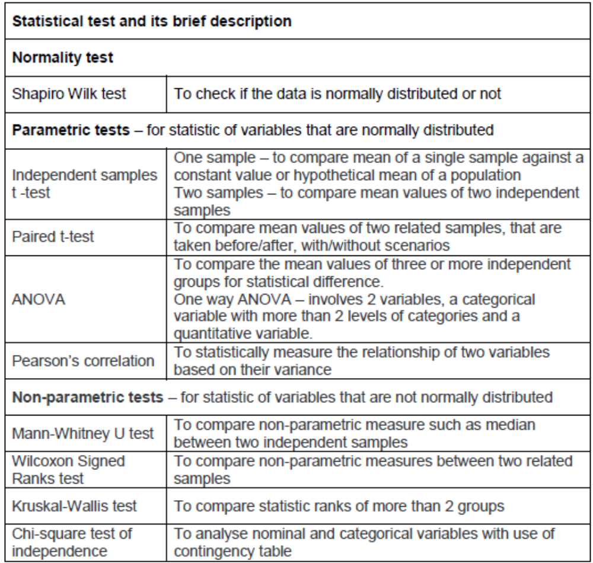
- Understanding the relationship between variables using correlation and linear regression analysis, predicting value of dependent variable and interpreting results in R
- Knowledge about Bayesian data analysis and its strengths and limitations
3.0 Activities carried out
In the course of this module, I carried out these activities independently to acquire the knowledge detailed in section 2.0.
Reading: I read the relevant chapters in the three core books listed in the module (Berenson et al., 2015; Bruce et al., 2020; Holmes et al., 2017), reading list and notes section in each unit, which provided the basis of my learning.
Lectures: I actively listened to the following lecture casts which were very useful in understanding principal points in each unit.
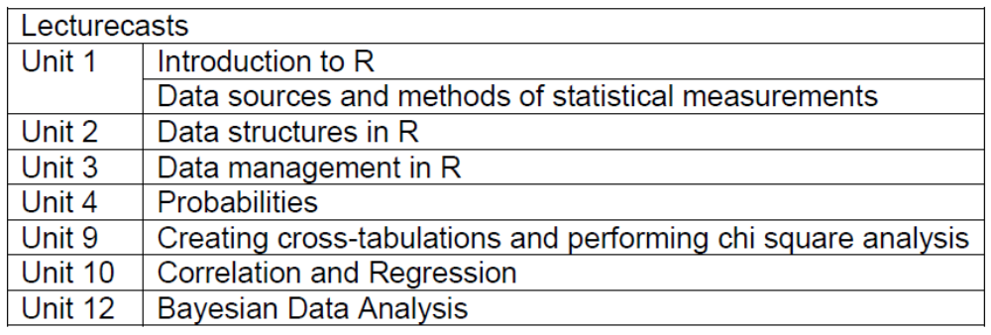
Seminars: I attended Tutor-led seminars offline which were very useful in all aspects, especially, in the preparation of module assessments such as the Mathematics test, Statistical analysis presentation and also this reflective writing.
Data activities: I independently performed the data activities in each unit using R Studio. These activities provided me confidence in applying statistical analysis tools in R to address research problems in a very practical way. Screenshots of activities performed attached in Appendix section
Module assessment: I carried out activities required for the statistical analysis presentation and Mathematics test.
Working out exercises in books: I worked out the solutions to the problems in the probability chapter of Holmes et al. (2017), which helped me to understand more about probability theory.
Tutorials: I watched several Khan Academy YouTube tutorials on statistics topics such as hypothesis testing, p values, probability and completed R tutorials in w3schools.
Discussion with others: I had verbal discussion with work colleagues about misinterpretations in using statistical tests on the basis of the guidelines reported by Greenland et al. (2017).
4.0 Emotional response and analysis
I had a very positive learning experience throughout this module. Progressing through each activity that I carried out, gave me more confidence, increased my interest and helped in more engagement on the subsequent activities.
Before this module, I had a good knowledge about the descriptive statistics, but inferential statistics was a grey area for me. Throughout this module, I had gained understanding about more practical ways to apply the acquired knowledge like what type of statistical test to perform for a given research problem, how to get the results with R and interpretation of results. I acquired more insights about applying my learned skills in my professional front. For example, at work I encountered a research question on comparing the dosimetric efficiency between two radiotherapy treatment techniques. I could immediately work out the type of data, samples required, ways of graphical data representation, appropriate statistical test to be used (paired t-test), defining the hypothesis and result interpretation using p-value.
I was a beginner to use R Studio, initially was challenging using it to import SPSS dataset, as the system couldn’t identify the location of library files and finally was able to fix it after a week of researching about R, through trouble shooting in R community blogs.
5.0 Learning and changed actions
This module involves learning of definitions, terminologies, concepts and number of statistical testing and interpretation methods that are required for gaining high level of knowledge and skills for statistical analysis. All the way through this module, I gained knowledge and practical skills through self-led learning process as reported by Hooshyar et al. (2020). I made notes while reading, attending seminars, lectures and tutorials and processed my thoughts during quite times to build a descriptive picture of all components that I learned, evaluated myself on my capability to use them fluently, prepared a personal learning plan with set targets and deadlines to meet, assessed my learning power (Deakin Crick, 2007) and regularly reviewed it to overcome the challenges that I faced. This helped in my learning process so that I am confident and I will not forget the skills that I learned in a long run.
6.0 Conclusion
In conclusion, I can confidently say that I feel equipped with knowledge and skills to perform statistical analysis, using R for any given research problem.
7.0 References
Berenson, L., Levine, D. & Szabat, K. (2015) Basic Business Statistics: Concepts and Applications. 13th ed. Pearson
Bruce, P., Bruce, A. & Gedeck, P. (2020) Practical statistics for data scientists: 50+ essential concepts using R and Python. O'Reilly Media.
Deakin Crick, R. (2007) Learning how to learn: the dynamic assessment of learning power. The Curriculum Journal 18(2): 135-153. DOI: https://doi.org/10.1080/09585170701445947
Greenland, S., Senn, SJ., Rothman, K. J., Carlin, B., Poole, C., Goodman, N., & Altman, G. (2016) Statistical tests, P values, confidence intervals, and power: a guide to misinterpretations. European journal of epidemiology 31(4): 337–350.
Holmes, A., Illowsky, B., & Dean, S. (2017) Introductory Business Statistics. OpenStax
Hooshyar, D., Pedaste, M, Saks, K., Leijen, A., Bardone, E., Wang, M. (2020) Open learner models in supporting self-regulated learning in higher education: A systematic literature review. Computers & Education 154(9): DOI: https://doi.org/10.1016/j.compedu.2020.103878.

8.0 Appendix: Evidence of activities done
